**NEXHIREAI**

A Capstone Project report submitted

in partial fulfillment of requirement for the award of degree

**BACHELOR OF TECHNOLOGY**

in

**SCHOOL OF COMPUTER SCIENCE AND ARTIFICIAL INTELLIGENCE**

By

**KUNDURU.SAI SRUTHI REDDY (2203A52156)**

**MACHARLA ROHITH (2203A52157)**

**SANGA AKHILANANDA TEJA (2203A52173)**

**SATKURI KAILASH (2203A52174)**

Under the guidance of

**Mr. Bediga Sharan**

Assistant Professor, School of CS&AI.



SR University, Ananthsagar, Warangal,Telagnana-506371

**SR University**

Ananthasagar, Warangal.

**

**CERTIFICATE**

This is to certify that this project entitled **“NEXHIREAI**" is the bona fied work carried out by **MACHARLA ROHITH, SANGA AKHILANANDA TEJA, SATKURI KAILASH and KUNDURU SAI SRUTHI REDDY** as a Capstone Project for the partial fulfillment to award the degree **BACHELOR OF TECHNOLOGY** in **School of Computer Science and Artificial Intelligence** during the academic year 2024-2025 under our guidance and Supervision.

| **Mr. Bediga Sharan** | **Dr. M. Sheshikala** |
| --- | --- |
| Assistant Professor, | Professor & Head,  School of CS&AI |
| SR University,  Ananthasagar, Warangal | SR University,  Ananthasagar, Warangal |
|  |  |

|  |  |
| --- | --- |
| **Reviewer-1** | **Reviewer-2** |
| Name: | Name: |
| Designation: | Designation: |
| Signature: | Signature: |

**ACKNOWLEDGEMENT**

We owe an enormous debt of gratitude toour Capstone project guide **Mr. Guide Name, Asst.Prof./Assoc Prof/Professor** as well as Head of the School of CS&AI, **Dr. M.Sheshikala, Professor** for guiding us from the beginning through the end of the Capstone Project with their intellectual advices and insightful suggestions. We truly value their consistent feedback on our progress, which was always constructive and encouraging and ultimately drove us to the right direction.

We express our thanks to project co-ordinators **Mr.** **Sallauddin Md, Asst. Prof.** for their encouragement and support.

Finally, we express our thanks to all the teaching and non-teaching staff of the department for their suggestions and timely support.

**CONTENTS:**

|  |  |  |
| --- | --- | --- |
| ****S. No.**** | ****Chapter / Section Title**** | ****Page No.**** |
|  | **Abstract** | **1** |
|  | **About the Organization or Company** | **2** |
|  | **Introduction of Project** | **3** |
|  | **Related Work** | **6** |
|  | **Problem Statement** | **9** |
|  | **Requirement Analysis, Risk Analysis and Feasibility Study** | **12** |
|  | **Proposed Solution / Approach / Technique** | **18** |
|  | **Architecture Diagrams, Flow Charts and DFD** | **23** |
|  | **Simulation Setup and Implementation** | **29** |
|  | **Result Comparison and Analysis** | **32** |
|  | **Learning Outcome** | **38** |
|  | **Conclusion with Challenges** | **40** |
|  | **References** | **43** |
|  | **Links / Other Artefacts of the Project (Appendix)** | **44** |

**LIST OF FIGURES:**

|  |  |  |
| --- | --- | --- |
| ****Fig. No.**** | ****Title of Figure**** | ****Page No.**** |
|  | System Architecture Diagram of NexHireAI | **24** |
|  | Data Flow Diagram (Level 0 and Level 1) | **26** |
|  | Data flow | **27** |
|  | execution process | **31** |
|  | comparative performance | **34** |
|  | accuracy comparison | **35** |
|  | Performance Comparison Metrics | **36** |

## **LIST OF TABLES:**

|  |  |  |
| --- | --- | --- |
| **Table No.** | **Title of Table** | **Page No.** |
|  | **Comparative Analysis Of Existing Approaches** | **12** |
|  | System Requirements | **14** |
|  | Risk Analysis Matrix | **15** |
|  | Estimated Cost Break Down | **16** |
|  | Software And Hardware Configuration | **29** |
|  | Performance Metrics Comparison | **32** |
|  | Comparative Analysis | **33** |
|  | Ai Scoring Accuracy Analysis | **34** |
|  | System Performance Evaluation | **35** |
|  | System Outcome Summary | **39** |

## **LIST OF ACRONYMS:**

|  |  |
| --- | --- |
| ****Acronym**** | ****Full Form**** |
| AI | Artificial Intelligence |
| UI | User Interface |
| DFD | Data Flow Diagram |
| UML | Unified Modeling Language |
| ATS | Applicant Tracking System |
| IDE | Integrated Development Environment |
| B2B | Business-to-Business |
| B2C | Business-to-Consumer |
| XP | Experience Points |
| API | Application Programming Interface |
| LLM | Large Language Model |

**ABSTRACT**

For many years, recruitment has been a slow, subjective, and time-consuming process. **NexHireAI** is a recruitment and learning-assistant platform that is driven by Artificial Intelligence, and it automates skill assessment and data-driven decisions for candidates and recruiters. It dynamically creates assessments tailored to the unique requirements of jobs, using **Google Gemini** (Genkit), and it scores answers using hybrid, deterministic, and AI-based scoring, and uses interactive dashboards and analytics to present results.

   The framework will be built on **Next.js 14, TypeScript, Firebase, Tailwind CSS,** and **Zustand** to guarantee the possibility of scale, privacy, and equal evaluation. Its game-based appearance serves as a spur to the involvement of learners and the recruiter module reveals the patterns of candidates performance, preparedness ratings, and skills profiles.

   NexHireAI by advancing the disjuncture between academic education and job opportunities fosters ethical AI operations and hiring choices. The project shows how smart automation, a human-centered design and accountable data management can transform recruitment into a flexible, impartial and effective environment.

**ABOUT THE ORGANIZATION OR COMPANY**

This project was created in the **School of Computer Science and Artificial Intelligence (CS & AI)** in SR University, Warangal. SR University is a very innovative institution in India with a focus on outcome and experiential learning. The university offers an atmosphere that fosters innovation, research and entrepreneurship, which allows them to put ideas into practice.

  Capstone Project Program is an integral component of SR University curriculum. It tries to prepare the students with industry-oriented skills through involving them in the practical solution of problems using the modern technologies. Students under this program operate in teams with the help of mentors to design, develop and implement effective solutions.

  NexHireAI is one of the results of this project. It is an amalgamation of Artificial Intelligence, Cloud Computing and Web Development to develop a scalable and ethical hiring company. The project is aimed at helping to solve one of the most serious global issues, which is fair and effective recruitment, combining data analytics, assessment based on AI, and usability.

  This project was done under the supervision of **Mr. Bediga Sharan**, the Assistant Professor, School of Computer Science and Artificial Intelligence, SR University. His supervision, technical advice, and positive feedback were used to assist the team in creating a complete and deployable product that has research support.

**Team Number:** 129

**Team Members:**

KUNDURU.SAI SRUTHI REDDY (2203A52156)

MACHARLA ROHITH (2203A52157)

SANGA AKHILANANDA TEJA (2203A52173)

SATKURI KAILASH (2203A52174)

# CHAPTER 1 – INTRODUCTION

## OVERVIEW

One of the most necessary and most complicated procedures in every organization is recruitment. It entails finding the appropriate talent, appraising technical and behavioral skills and matching them with organizational requirements. Nevertheless, the conventional recruitment mechanisms are usually associated with inefficiencies in forms of manualized screening, time wastage, human subjectivity and the absence of a feedback system.

   In the modern data-oriented world, Artificial Intelligence (AI) is changing the world of industries, and recruitment is not no exception. The objectives of NexHireAI include automated optimization of the evaluation process through AI-based evaluation and real-time analytics to redefine the recruitment process. The platform offers a flexible, objective, and effective means of recruiters to find potential candidates as well as applicants to gain valuable feedback on their performance.

   In contrast to the traditional assessment systems that use fixed question libraries, NexHireAI dynamically generates questions with the help of Google Gemini (Genkit) and scores the answers using a hybrid scoring system, a combination of deterministic scores with AI-based analysis. This makes all tests individual, adaptive and in line with those in the real world.

  The final vision of NexHireAI is to establish an ethical, intelligent and scalable recruitment ecosystem that will bridge the gap between job-seeking individuals, schools and colleges and employers using the responsible use of AI technology.

## **OBJECTIVES OF THE PROJECT**

   The primary goal of NexHireAI is to develop AI that will enhance the hiring process of both recruiters and candidates. The project aims at developing an intelligent recruitment platform that would not only automate the evaluation but also enhance learning and development.

The specific objectives are:

1. To create an AI-based evaluation system that will dynamically create tests depending on the position and level of the candidate.
2. To offer a complete view of the performance measurement via the dashboards that illustrate scores, progress and gaps in skills.
3. To include a feedback and learning system that suggests resources and areas of practice depending on the outcomes of evaluations.
4. To be fair, transparent, and secure with ethical practices of AI.
5. To provide recruiters with sophisticated analytics to compare, shortlist and evaluate them in an objective manner.
6. To add gamification functionality in order to make users more engaged and motivated.

## SCOPE OF THE PROJECT

NexHireAI is applicable in various domains of the recruitment and professional development. It is implemented to support the students, job seekers, recruiters and the corporate organizations to establish a smooth hiring and upskilling process.

To the candidates, the system provides AI-based tests, real time scores and feedback. In the case of recruiters, it provides AI-powered analytics, candidate preparedness, and performance visualizations. Also, the system can be utilized by the institutions to track the progress of the employability and development of the skills of the students over time.

The modular architecture of the platform can be customized and scaled. It is highly adaptable to any industry such as IT, data analytics, design, or business and could therefore be useful both in academia and in corporations. NexHireAI is also capable of integration with the systems that already exist such as Applicant Tracking Systems (ATS) and Learning Management Systems (LMS) to increase its functionality.

* 1. **SIGNIFICANCE OF THE PROJECT**

  The post-digital generation requires organization to have quick, objective, and data-driven recruitment solutions. The conventional recruitment systems have constraint of manual procedures and fail to give actionable information. To remove these shortcomings, NexHireAI provides an integrated recruitment experience that integrates Artificial Intelligence, Cloud Computing, and Data Visualization.

What is important about NexHireAI is that it can facilitate ethical hiring. It is also objective and not based on human bias in that skills are evaluated without any influence of human factors. It saves time and costs of recruitment through automating the assessment and consistency and accuracy are not compromised. Genkit AI model is used to provide the flexibility of generating new questions, and thus, the process is efficient and safe.

To candidates, it can serve as a career advisor to oneself and provide learning feedback and guidance depending on their test results. To recruiters, it serves as a decision-support tool, since it allows the recruiter to filter out the most suitable candidates in the shortest time possible, with the help of AI-generated insights.

Therefore, NexHireAI does not only enhance technological innovation but social responsibility of creating equal hiring opportunities, a genuine combination of innovation, morality, and impact.

**CHAPTER 2 – RELATED WORK**

**2.1 INTRODUCTION**

  Artificial Intelligence (AI) and Machine Learning (ML) have become the forces of change in the fast-changing world of recruitment technology. Companies are currently using these technologies to automate their screening of candidates, online testing, and job compatibility. NexHireAI was inspired by the fact that the current tools are efficient in certain domains, but fail to offer a more adaptive, fair and feedback-focused recruitment experience.

The chapter mentions the research studies, industry tools and technologies that inspired the creation of NexHireAI, as well as highlighting the gaps that the proposed system will focus on filling.

**2.2 EXISTING SYSTEMS AND LIMITATIONS**

   A few of the current mainstream platforms that dominate the recruitment and evaluation market are LinkedIn Assessments, HackerRank, Codility, and Mettl. Although online tests and evaluations are offered by these tools, they are not very flexible and personalized as they imply pre-determined question banks.

The available systems are mostly more technical and ignore the possibility of soft skills or learning. Moreover, they fail to provide dynamic information on the strengths, weaknesses of the candidate or improvement areas. These restrictions render the systems of traditional recruitment inflexible and time consuming. No dynamic question generation - there is a tendency to use the same question to several users.

1. Limited feedback - candidates are only scored on a final basis and not on learning.
2. Subjective question dependency on manual evaluation.
3. Possible bias in the difficulty of question and ranking of candidates.
4. There is no real-time analytics that recruiters can use to monitor the progress of their candidate.

Therefore, an increasing necessity to personalize, integrate AI-based recruiting solutions, and analytics is becoming more and more popular to support various needs of contemporary hiring processes.

**2.3 RESEARCH IN AI-BASED RECRUITMENT SYSTEMS**

Recent scholarly studies outline the benefits of AI and data analytics in making recruitment more accurate and fair. AI algorithms are able to forecast success of the candidates, identify skill deficiencies, and even evaluate behavioral characteristics through evaluation data.

Research like the article by the IEEE, titled AI for **Human Resource Management, (IEEE, 2022)** has demonstrated that machine learning-driven scoring systems can help minimize biases in hiring and increase the level of decisions. On the same note, **Natural Language Processing (NLP)** frameworks have also been adopted to automatically evaluate descriptive responses and logic codes.

Nevertheless, it is difficult to guarantee the level of transparency, explainability, and ethical AI activities. With the emergence of **Explainable AI (XAI)** methods, there are new opportunities to make sure that recruiters are aware of how AI comes to its decisions, which is one of the key elements in developing trust and acceptance.

**2.4 COMPARATIVE ANALYSIS OF EXISTING APPROACHES**

|  |  |  |  |
| --- | --- | --- | --- |
| **Platform** | **Approach** | **Strengths** | **Limitations** |
| **LinkedIn Assessments** | Static question-based | Large user base, verified badges | Lacks adaptiveness, no AI scoring |
| **HackerRank** | Code-based testing | Real-world coding tests | Limited personalization |
| **Mettl** | Psychometric + technical tests | Enterprise-ready | Expensive, non-customizable |
| **Codility** | Algorithmic challenge platform | Excellent for technical roles | Limited analytics |
| **NexHireAI (Proposed)** | AI-based adaptive system | Real-time feedback, analytics, fairness | Research and scalability in progress |

  Based on the table, it can be seen that the majority of current systems are not fully automated and do not have AI-based feedback and adaptive question modeling. NexHireAI is intended to bridge this gap by determining to **combine intelligent generation, ethical assessment,** and **interactive** dashboards in a single unified system.

**2.5 RESEARCH GAP IDENTIFICATION**

   The gaps in the research have been identified as follows:

1. Lack of real time, adaptive generation of questions on an individual basis.
2. The absence of extensive analytics to analyze the performance trends.
3. Minimal application of AI in the delivery of individual feedback or learning opportunities.
4. Very little attention paid to the impartiality, confidentiality, and transparency of AI-driven recruitment systems.

# CHAPTER 3 – PROBLEM STATEMENT

## **3.1 INTRODUCTION**

  The current recruitment ecosystem is based on the digital platform where organizations predominantly use it to determine and screen prospective candidates. Most of the hiring processes are manual, time-consuming and subjective, despite the advancement in technology. The challenges that recruiters have to deal with include processing high volumes of applications, authenticating the claims in the skills, and making unbiased choices.

On one hand, candidates experience uncertainty and lack of feedback and therefore they are always unable to know their skill deficits and how to prepare better to the jobs. Most of the assessment tools currently in use rely on a fixed set of questions, multiple choice tests and other conventional means of evaluation that does not accurately portray job readiness in the real world.

Therefore, the desire to obtain an intelligent, adaptive, and transparent system, allowing to automatize the evaluation of the candidates, is quite and quite high and guarantees such processes as fairness, scalability, and continuous learning. This is the reason why NexHireAI, an AI-based recruiting and learning support system, was developed.

## **3.2 STATEMENT OF THE PROBLEM**

  The legacy recruitment process is ineffective, discriminatory and does not have insightful data. The process of screening resumes, interviewing repetitively, and non-adaptive testing systems that do not test potential are done manually by recruiters. Equally, the candidates are not given much feedback on their performance and thus no meaningful self-improvement is facilitated.

The current systems are partially automated yet they are unable to deal with three essential matters:

1. **Absence of Adaptiveness:** Tests are taken by all applicants regardless of their talent and position.
2. **Absence of Transparency:** Explainable evaluation reports based on data are seldom provided to the candidates and recruiters.
3. **Absence of Fairness:** It is possible to be subject to subjective bias or lack of evenness in the level of difficulty.
4. Thus, the main issue is:

To create and develop an Artificial Intelligence-powered recruitment system that dynamically builds adaptive, role-based tests, applies AI scoring to evaluate candidates, and delivers practical suggestions to the candidates and recruiters based on a fair, transparent, and ethical system.

The given issue reinforces the necessity to not only automate the recruitment process but also humanize it, make it **comprehensible,** and **learning-oriented**.

## **3.3 NEED FOR THE STUDY**

  The success of an organization in the ever competitive job market is determined by the quality of recruitment. The conventional modes of hiring can no longer be considered adequate because they relied on manual analysis, human factor, and were not scalable. Lack of adaptive testing and real-time analytics lead to ineffective decision-making and wasting of potential talent.

To reduce these restrictions, NexHireAI is going to use Generative AI (Google Gemini Genkit) to create questions, Firebase to store data on a scale, and Next.js to provide a smoother user experience. The system is centered on the use of AI in an ethical way, and the hiring decisions will be based on data and will remain objective.

In addition, the paper adds to the newly developing area of AI Ethics in Recruitment where transparency, privacy, and accountability play an important role. NexHireAI fosters a smarter, more informed decision by promoting fairness and continuous learning that allocate candidates and employers to make grab opportunity.

## **3.4 OBJECTIVES OF THE STUDY**

  The main purpose of the proposed research is to introduce an AI-powered recruitment process that will increase the efficiency, fairness, and interest of hiring.

The objectives are:

1. To robotize the assessment of candidates with adaptive AI-created tests.
2. To reduce bias and subjectivity utilizing clear AI algorithms.
3. To deliver analytical dashboards to recruiters to aid them in making decisions based on data.
4. To provide the candidates with a personalized feedback and skill suggestions.
5. To provide the ethical, secure, and privacy-compliant use of the data concerning the candidates.

## **3.5 SCOPE OF THE STUDY**

    NexHireAI is capable of covering the whole recruitment lifecycle - assessment creation through analytics-driven hiring. The project aims at developing a scalable, web-based application, which combines the principles of AI, cloud services, and user-centered design.

The platform has two large classes of users:

Candidates: Able to take AI-generated exams, see live performance scores and have learning advice.

Recruiters: Are able to access analytics dashboards, skill maps and comparison charts to make evidence-based hiring decisions.

The research only goes as far as to develop a functional prototype that proves the validity of AI-based hiring. Nevertheless, the architecture can be extended in the future including the functions of **Applicant Tracking Systems (ATS), corporate job portal** and **educational placement cell integration**.

# *****CHAPTER 4 – REQUIREMENT ANALYSIS, RISK ANALYSIS, AND FEASIBILITY STUDY*****

There must always be a comprehensive analysis of the requirements and feasibility of any software system that is to be designed and implemented. This makes the system technically feasible as well as being of practical use. NexHireAI is an automation recruitment system that is based on the cloud and aimed at smartly recognizing and evaluating the capabilities of the candidates with the help of the **Artificial Intelligence (AI).**

The following chapter is an account of the **functional requirements, non-functional requirements, risk assessment,** and **feasibility study** of NexHireAI. It outlines what the system is supposed to do, the limitations within which the system is required to work and what makes it be successfully implemented.

## **4.1 REQUIREMENT ANALYSIS**

  Requirement analysis refers to the art of comprehending the needs and expectations of the users as well as defining how the system will address these needs. In the case of NexHireAI, the requirements have been categorized into two groups, which are functional and non-functional.

## **4.1.1 FUNCTIONAL REQUIREMENTS**

  The functional requirements tell how the system will perform certain services and operations.

1. **User Authentication:**  
     The system will enable users (candidates and recruiters) to create accounts and log in with the help of email or Google authentication with the help of Firebase.
2. **Role-Based Access:**  
     It will consist of two significant positions - Candidate and Recruiter. Applicants are able to complete tests and recruiters can access dashboards and analytics.
3. **Assessment Creation:**  
     The system will dynamically create AI-based assessment through **Google Gemini** (Genkit) on the job position and level of skills.
4. **Assessment Execution:**  
     Applicants have the option of attempting tests consisting of coding and multiple-choice as well as descriptive questions in a computerized format which has a time counter and a test progress bar.
5. **Automated Evaluation:**  
     It will automatically rate the responses by the hybrid scoring system which will involve the combination of deterministic logic (objective answers) and AI-based logic (subjective and code-based answers).
6. **Performance Analytics:**  
     Interactive dashboards allow recruiters to see detailed reports with candidate rankings and skill proficiency level as well as pre-readiness scores.
7. **Feedback and Learning Recommendations:**  
     The applicants will be provided with AI-generated feedback that will highlight their weaknesses, strengths, and their individual learning routes to work on.
8. **Gamification:**  
     The platform will give experience points (XP), badges, and achievements to the candidates to encourage the candidates and keep them attracted.

## **4.2.2 NON-FUNCTIONAL REQUIREMENTS**

  Non-functional requirements are the performance standards, constraints and quality attributes of the system.

1. **Scalability:**  
     The platform should be able to accommodate a high user count at the same time using Firebase Cloud and Vercel hosting.
2. **Security:**  
     The data should be encrypted and kept in Firestore. It should be authenticated as per the OAuth 2.0 to provide confidentiality.
3. **Usability:**  
     The system user interface must be user-intuitive and must be based on the principles of User-Centered Design (UCD).
4. **Reliability:**  
     The platform must have a 99 percent uptime and fewer service interruptions.
5. **Performance:**  
     The loading of the page time must be not more than 2 seconds and evaluation outcomes must be done in real time.
6. **Portability:**  
     The app must be cross-brower and cross-device (desktop, tablet and mobile) compatible.
7. **Maintainability:**  
      They should maintain simple to upgrade AI models, user interface, and database schemas.
8. **Ethical AI Compliance:**  
     The AI models should be fair without any gender, racial, and academic bias.

## **4.3 SYSTEM REQUIREMENTS**

  A software and hardware are required to implement the NexHireAI effectively.

|  |  |
| --- | --- |
| **Requirement Type** | **Specification** |
| **Frontend Technology** | Next.js 14, TypeScript, Tailwind CSS, ShadCN UI |
| **Backend / Database** | Firebase Authentication, Firestore Database |
| **AI Framework** | Google Gemini (Genkit) API |
| **State Management** | Zustand |
| **Deployment Platform** | Vercel (Frontend) and Firebase Cloud |
| **Hardware Requirements** | Intel i5 or above, 8GB RAM, 10GB disk space |
| **Software Tools** | VS Code, GitHub, Node.js, Browser (Chrome/Edge) |

## **4.4 RISK ANALYSIS**

  Risk analysis can be used to determine threats in the development and deployment. Analysis of the risks is done according to the probability and impact with mitigation strategies.

|  |  |  |  |
| --- | --- | --- | --- |
| **Risk** | **Impact** | **Likelihood** | **Mitigation Strategy** |
| AI Model Bias | High | Medium | Regular testing of AI data sets for fairness |
| Data Security Breach | High | Low | Encryption and strict Firestore access rules |
| Network Downtime | Medium | Medium | Use of Vercel autoscaling and caching mechanisms |
| API Failure (Gemini) | High | Low | Implement fallback question sets |
| UI Rendering Issues | Medium | Medium | Cross-device responsive design testing |
| Overload of Database Requests | High | Medium | Use Firestore batching and caching |
| User Dropout / Low Engagement | Medium | High | Implement gamification and reminders |

## **4.5 FEASIBILITY STUDY**

  The feasibility study is used to assess the possibility of developing the system and which constraints of technology, budget, and operational efficiency the system can be developed within. It also makes NexHireAI not only work but also be economically and technically feasible.

## **4.5.1 TECHNICAL FEASIBILITY**

  The technological implementation of the system is also viable because it applies tested and scalable technologies, including Next.js, Firebase, and Google Genkit. Each of the frameworks is an open-source one that is cloud-compatible and is easy to maintain. High reliability and flexibility are guaranteed by using modern tools of management of the state, such as Zustand and serverless functions in Firebase Cloud.

## **4.5.2 ECONOMIC FEASIBILITY**

  The economic feasibility is a determination of the cost-efficiency of the project. The cost of operation is greatly lowered since the system depends on free-tier or pay as you go cloud service.

**Estimated 3-Year Cost Breakdown:**

|  |  |
| --- | --- |
| **Cost Component** | **Estimated Cost (USD)** |
| Labor (Development, Testing, Maintenance) | $530,000 |
| Cloud & Software Services | $53,000 |
| AI API & Hosting | $8,000 |
| Marketing & Deployment | $25,000 |
| **Total Estimated Cost** | **≈ $610,000** |

  Given the scalability and potential commercial model (B2C + B2B plans), the cost is justified and sustainable.

## **4.5.3 OPERATIONAL FEASIBILITY**

  In its operational view, NexHireAI is considerably highly automated requiring minimal manual interventions. The tests and analytics can be managed by the recruiters through dashboards and accessed by the candidates directly.

This is because the cloud-hosted model is fully reliable and accessible as well as easy to maintain. Corporation and academic integration also increases operational efficiency.

## **4.5.4 LEGAL AND ETHICAL FEASIBILITY**

  NexHireAI complies with the law and ethics of using Artificial Intelligence and data privacy. The information of users is kept safely and not a single piece of personal information is provided without authorization. The algorithms applied to the platform are aimed at fostering equality and removing the discrimination within the platform depending on gender, race, or academic background. The current chapter outlined the needs, possible threats, and viability of the NexHireAI system. As the analysis has shown, the project has proven to be technically feasible, cost effective and operationally sustainable.

In the following chapter, the Proposed Solution and System Design will be done where the architecture, workflow, and technical models of NexHireAI will be described in detail.

# ****CHAPTER 5 – PROPOSED SOLUTION / APPROACH / TECHNIQUE****

## **5.1 INTRODUCTION**

  The classical recruitment ecosystem is plagued by such issues as bias, inefficiency, and scalability. To resolve these problems, NexHireAI serves as an answer to the situation, integrating the concept of Artificial Intelligence, Cloud computing, and Data Visualization into a single platform that can automate evaluations, increase the level of fairness, and assist in decision-making.

The solution that is being proposed is NexHireAI which is a web-based application developed using the latest technologies and is based on Next.js 14, TypeScript, Firebase, and Google Gemini (Genkit). It also allows candidates to have dynamic tests and recruiters to see AI-based information on candidate preparedness, skill performance and areas of improvement.

The strategy is based on the development of a User-Centered Design (UCD), simplicity, efficiency, and transparency of the entire recruitment procedure.

## **5.2 THE OVERALL ARCHITECTURE OF THE SYSTEM**

  NexHireAI has a modular, distributed, and cloud-native architecture. It is composed of the following significant parts:

**Frontend Interface (Client Layer):**  
   This layer is constructed based on Next.js 14 and Tailwind CSS and handles user interaction. It has the login screen, the assessment screens, dashboards, and analytics screens. The Firebase connect via APIs to retrieve data.

**Application Logic Layer:**  
  The business logic is in the core. It handles:

- Question generation with AI and Google Gemini Genkit.

- Flow control in assessment by Zustand (state management).

- Dynamic candidate and recruiter dashboard routing.

1. **Backend and Database Layer:**  
      Firebase Cloud Functions and Firestore Database, this serves as a middle layer which is responsible for the authentication and storage of data, AI results and performance measurements.
2. **AI Engine (Cognitive Layer):**  
      This layer creates on the fly role specific questions, real-time exercise correction, specially designed coding exercises based upon Artifical Intelligence.
3. **Data Analytics and Visualization Layer:**  
     Scores, skill matrixes and performance trends are available through an interactive dashboard with visualization (with libraries like **Recharts** and **ShadCN UI**).
4. **Hosting and Deployment Layer:**  
     Vercel is used as the frontend and Firebase Hosting as the backend API to deploy the platform, which is guaranteed to scale globally and be online at all times.

## **5.3 PROPOSED METHODOLOGY**

  NexHireAI has a methodology that is a combination of deterministic analysis and AI analysis. The workflow is divided into the following way:

### ****Step 1: User Registration and Authentication of the user****

  The candidates and recruiters are registered through Firebase Authentication. Sign-in options ( email or Google) are secure and ensure privacy of data and user identification.

### ****Step 2: Role-Based Interface****

Once they log in they are redirected to distinct dashboards:

**- Candidate Dashboard:** All the assessments, XP levels, and feedback are displayed.

- **Recruiter Dashboard:** Displays analytics of candidates, skills and hiring recommendations.

### ****Step 3: AI-Powered Assessment Generation****

### The ability of NexHireAI to produce assessment generation is based on the Gemini Genkit API to generate adaptive tests.

### - The AI narrows down to questions depending on the type of job (Frontend Developer, Data Analyst, etc.).

### - Question difficulty is dynamically adjusted according to the responses of the user.

### ****Step 4: Assessment Execution****

   Test Run Interface is used by candidates to practice multiple choice, coding and descriptive questions. Indicators, timers and checks on submission make the process smooth.

### ****Step 5: Hybrid Evaluation Model****

  The system conducts the evaluation of responses in two phases:  
  - **Rule-Based Evaluation:** Rule based answer keys are used to automatically evaluate objective (MCQ's) questions.

  - **AI-Based Evaluation:** There is the use of AI on subjective and coding questions to determine their correctness, logic, and efficiency.

**Step 6: Score Calculation and Feedback Generation**

   The functionality of **ScoreAssessmentFlow** Odds calculates the final score based on a combination tof the deterministic and AI-based scores. we can improve and receive personal learning recommendations.

**Step 7: Dashboard Visualization**

  The output is displayed in the form of charts, graphs and progress indicators that enable recruiting officers to track the performance patterns and to compare the applicants at ease.

## **5.4 UNIQUE FEATURES OF NEXHIREAI**

1. **Adaptive Assessment Creation:**  
     The tests are all distinctive, dynamically generated depending on the end-user skills and role context on a generative AI basis.
2. **Hybrid AI Scoring Mechanism:**  
     The system offers real-time feedback and analytics to end users, including suppliers and customers.
3. **Gamified Learning:**  
     Rewards users through badges, tracking progress and XP points as a way of motivating them to keep participating. The ethical duty to adhere to the privacy policy of information utilized in the research and to comply with data privacy legislation.
4. **Data Privacy and Ethical Compliance:**  
     The ethical obligation to abide by the privacy policy of data used in the study and to observe data privacy laws. Has stringent data-handling standards which guarantee transparency, fairness and control by users.

## **5.5 DESIGN PRINCIPLES FOLLOWED**

## **1.User-Centered Design (UCD):**   The interfaces are all user-friendly, clear, and consistent.

## **2.Modular Architecture:**   Allows UI, backend and AI development to be done independently.

## **3.Scalability:**   The deployment of the platform is on cloud so that it can support thousands of users at a time.

## 4.**Maintainability:**   It is easy to make future updates due to the code modularity and version control (GitHub).

## 5.**Ethical AI Design:**   Assures equity, confidentiality and non-discriminatory algorithms to all candidates.

## **5.6 TECHNOLOGICAL STACK**

|  |  |  |
| --- | --- | --- |
| **Component** | **Technology Used** | **Purpose** |
| Frontend | Next.js 14, TypeScript, Tailwind CSS | UI/UX and routing |
| Backend | Firebase, Firestore | Authentication and database |
| AI Integration | Google Gemini (Genkit) | Question generation and scoring |
| State Management | Zustand | App state handling |
| Hosting | Vercel, Firebase Cloud | Deployment |
| Visualization | Recharts, ShadCN UI | Dashboards and analytics |
| Version Control | GitHub | Collaboration and code management |

## **5.7 SYSTEM INNOVATION**

  NexHireAI is a **self-learned AI loop** that is not like a conventional assessment tool. The AI uses the trends of user performance and then optimizes the further measurements. It gets increasingly correct in regard to predicting preparedness and recommending custom learning resources.

This lifelong learning model will allow NexHireAI to improve as the database grows, and hence it is a sustainable and intelligent recruitment ecosystem.

## **5.8 SUMMARY**

  This chapter introduced the suggested **architecture, methodology,** and **new design strategy** of NexHireAI. The solution combines dynamic evaluations, moral human AI assessment with analysis results in an uninterrupted recruitment process.

The topic of the next chapter will be based on **Architecture Diagrams, Flowcharts,** and **Data Flow Diagrams (DFD)**, a visual representation of logical and functional flow of the system..

# ****CHAPTER 6 – ARCHITECTURE DIAGRAMS, FLOW CHARTS, AND DATA FLOW DIAGRAMS****

## **6.1 INTRODUCTION**

  System architecture and data flow diagrams provide a clear understanding of how different modules of a system interact and exchange information. These diagrams play a crucial role in visualizing the **logical flow**, **data movement**, and **module dependencies** within a software system.

  For the **NexHireAI** platform, architecture diagrams and flowcharts demonstrate how AI, cloud services, and user interfaces work together to automate recruitment and assessment processes. This chapter explains the design architecture, control flow, and the data flow across the various components of the system.

## **6.2 SYSTEM ARCHITECTURE**

**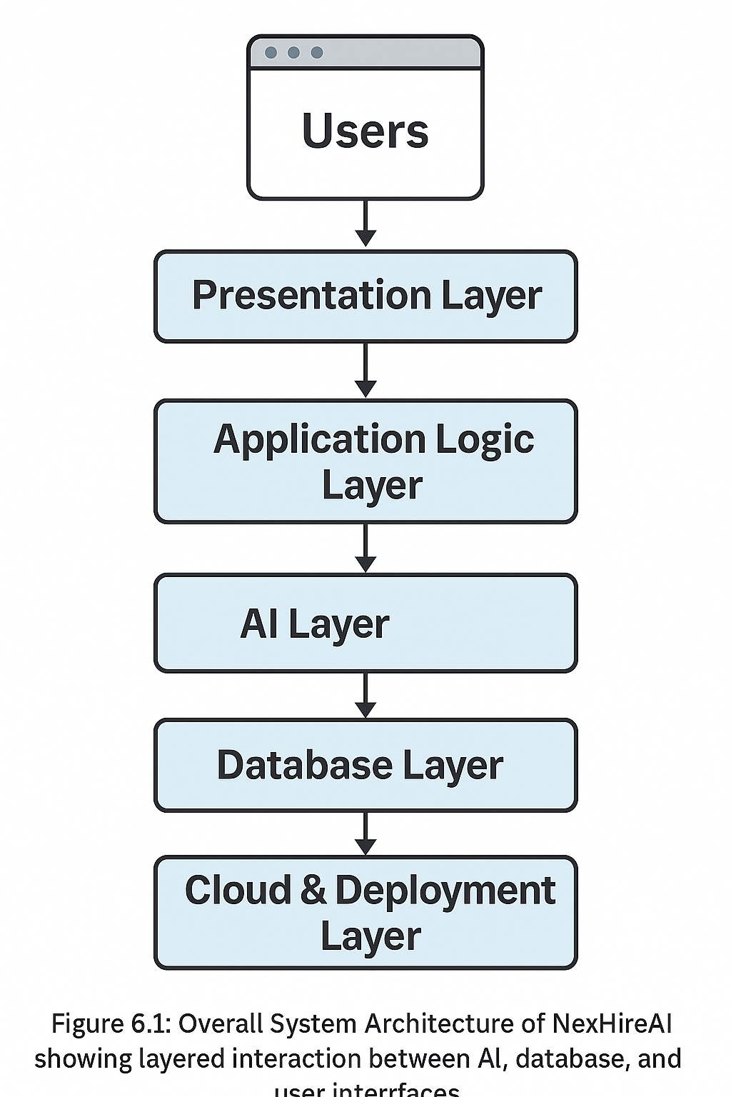**

**1.Presentation Layer:**  
  This layer handles user interaction. It includes user dashboards, assessment screens, and feedback pages built using **Next.js 14** and **Tailwind CSS**. It ensures smooth, responsive, and intuitive UI experiences for both recruiters and candidates.

**2.Application Logic Layer:**  
  The middleware that manages the app’s flow and state. It handles communication between frontend and backend components using **Zustand** for state management and **Firebase APIs** for logic control.

**3.AI Layer (Intelligence Engine):**  
  This layer uses **Google Gemini (Genkit)** to dynamically generate questions and evaluate answers. It also provides adaptive feedback, learning recommendations, and candidate scoring using AI reasoning.

4.**Database Layer:**  
  Managed by **Firebase Firestore**, this layer stores all structured data including user profiles, assessment records, feedback, and analytics.

5.**Cloud & Deployment Layer:**  
  Includes **Vercel** (frontend hosting) and **Firebase Cloud Functions** for backend services. It ensures high performance, real-time synchronization, and global scalability.

**System Architecture Description:**

* **Users (Candidates and Recruiters)** interact with the platform through web browsers.
* **Requests** are processed through the frontend interface, which communicates with the backend services via secure APIs.
* **Firebase Authentication** manages secure logins and session validation.
* **AI Engine (Gemini)** receives role-specific parameters and generates assessment content dynamically.
* **Evaluation Module** computes hybrid scores by combining deterministic and AI-based results.
* **Analytics Dashboard** retrieves data from Firestore and visualizes it using **Recharts**
* **Reports and Feedback** are then presented to the users in real time.

## **6.3 FLOW CHART OF THE SYSTEM:**

  The flow chart represents the **sequence of operations** and decision-making flow in NexHireAI. It shows how data moves through various processes from login to feedback.

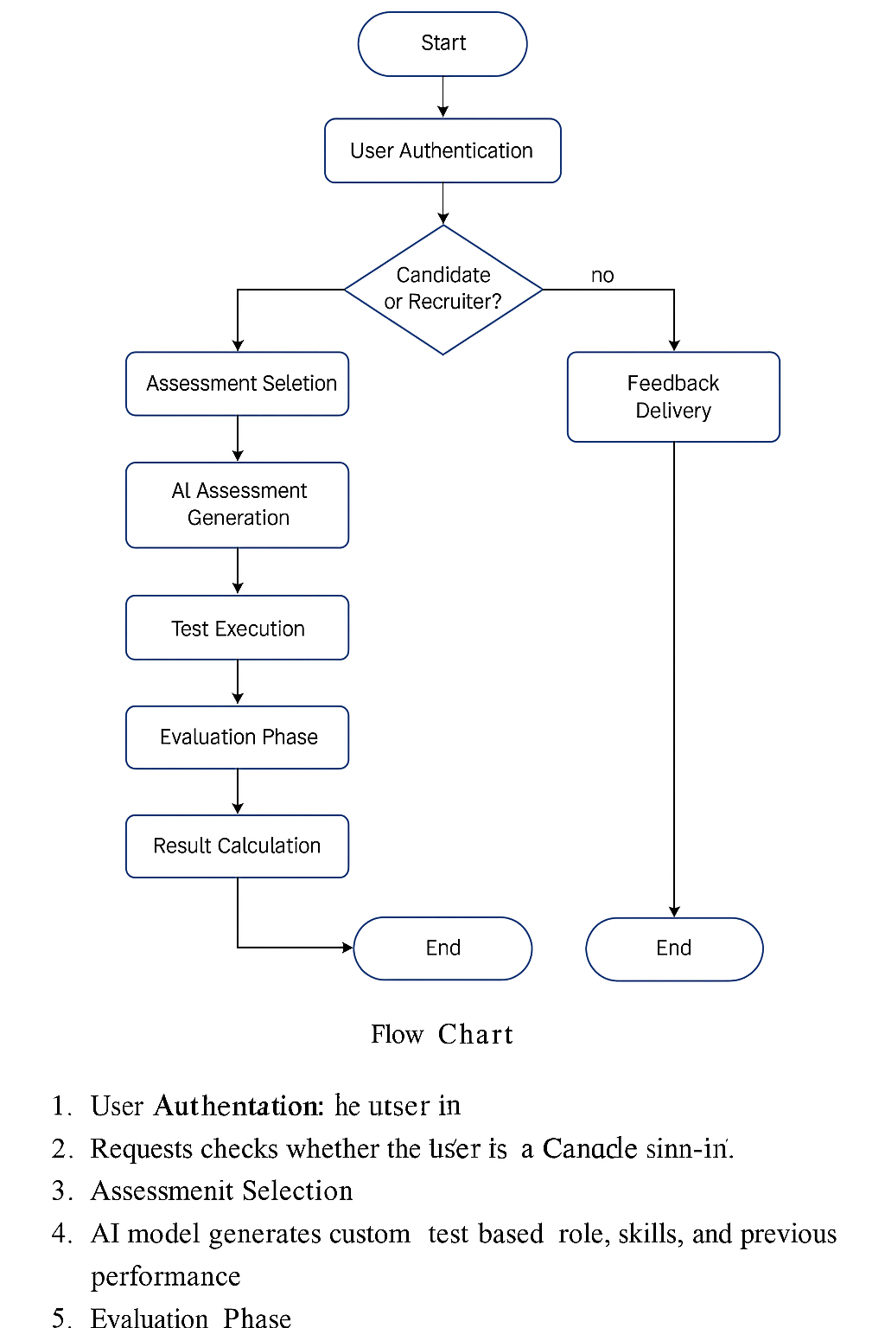

### ****Flow Description:****

### ****User Authentication:**** The user logs in using email or Google sign-in.

### ****Role Identification:**** The system checks whether the user is a Candidate or Recruiter.

### ****Assessment Selection:**** Candidates choose the desired role-based test.

### ****AI Assessment Generation:**** The AI model generates a custom test based on role, skills, and previous performance.

### ****Test Execution:**** The candidate completes the test, and answers are stored in Firestore.

### ****Evaluation Phase:**** AI and deterministic models process the responses.

### ****Result Calculation**:** Final scores and analytics are generated.

### ****Feedback Delivery:**** Candidates receive learning feedback, while recruiters receive analytics reports.

## **6.4 DATA FLOW DIAGRAMS (DFD)**

  The **Data Flow Diagram (DFD)** provides a detailed representation of how data moves within the system, depicting all external entities, data stores, and major processes. It helps to visualize the structure and dependencies in the recruitment system

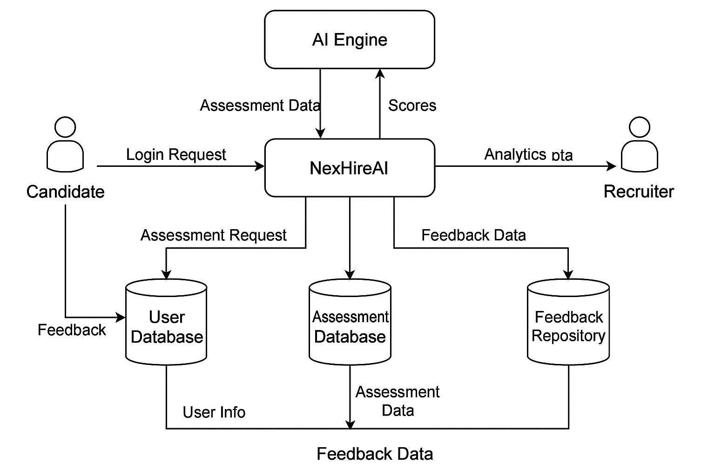

## **6.4.1 LEVEL 0 DFD (CONTEXT DIAGRAM)**

  The **Level 0 DFD**, or **Context Diagram**, provides an overview of NexHireAI as a single process interacting with external entities.

* **Entities:** Candidate, Recruiter, and AI Engine.
* **Processes:** Assessment Generation, Evaluation, Feedback.
* **Data Stores:** User Database, Assessment Database, Feedback Repository.

**Data Flow Summary:**

* Candidates submit login and assessment requests.
* Recruiters request analytics data.
* The AI engine exchanges data for generating and scoring assessments.
* Firestore stores and retrieves relevant data for both users.

## **6.4.2 LEVEL 1 DFD**

  The **Level 1 DFD** expands the main process into sub-processes such as authentication, test management, and analytics.

**Processes:**

1. **Authenticate User:** Validates credentials through Firebase.\
2. **Generate Assessment:** Creates adaptive questions using AI.
3. **Conduct Assessment:** Manages timing, question flow, and submissions.
4. **Evaluate Responses:** Applies AI-based and deterministic scoring.
5. **Display Results:** Generates reports and visual dashboards.

## **6.4.3 LEVEL 2 DFD**

  The **Level 2 DFD** shows detailed data movement between internal processes and external entities.

**Flow Description:**

* User data is verified during login.
* AI-generated questions are fetched from the Gemini API and stored in Firestore.
* Responses from candidates are submitted and processed by the scoring engine.
* Final reports and feedback are delivered to both candidate and recruiter dashboards.

# ****CHAPTER 7 – SIMULATION SETUP AND IMPLEMENTATION****

System architecture and data flow diagrams give a good picture regarding the interaction and exchange of information among the various modules of a system. These diagrams are important in visualizing logical flow, movement of data as well as dependencies of modules in a software system.

In the case of the NexHireAI platform, it is illustrated in the form of architecture diagrams and flowcharts, showing how AI, cloud services, and user interfaces interact to automate the process of recruitment and assessment. The project was implemented **Visual Studio Code** and **GitHub**.

**Software & Hardware Configuration**

|  |  |
| --- | --- |
| Component | Specification |
| Processor | Intel Core i5 / i7 |
| RAM | 8 GB minimum |
| Storage | 512 GB SSD |
| OS | Windows 10 / 11 |
| Server Runtime | Node.js 20 + |
| Database | Firebase Firestore |
| Hosting | Vercel / Firebase Cloud Functions |
| Libraries | Zustand, Recharts, ShadCN UI, Gemini SDK |
| IDE | Visual Studio Code |
| Browser | Google Chrome (latest) |

## **Implementation Modules**

1. **Authentication Module**  
    This is the layer of user interaction. It consists of user dashboards, evaluation screens, and feedback pages composed of Next.js 14 and Tailwind CSS. It provides without any problems in terms of UI responsiveness, smoothness and intuition to the recruiters and the candidates.
2. **User Dashboard Module**  
     Dashboards are role-oriented and present information depending on the user type. Candidates see tests, performance and AI generated feedback recruiters see analytics, candidate progress and reports. Zustand takes care of global state management and ShadCN UI as well, which is purposed to contain those reusable interface elements.
3. **Assessment Generation Module**  
     Assessments are generated automatically from the Google Gemini Genkit, an AI engine. We pass parameters, such as job role, difficulty and generate unique questions to store in Firestore. This results in adaptive, non-repeated tests which have relevance to the role.
4. **Evaluation and Scoring Module**  
     Objective questions are marked using the keys and Coding & Descriptive Questions are evaluated using Gemini’s semantic engine. The results from deterministic and AI-based assessment are combined to get the final results, which are saved in the Firestore Results collection.
5. **Analytics and Feedback Module**  
    Recharts are used to render real-time analytics dashboards. There will be an ability to see skill matrices, average performance, and completion trends as demonstrated to the recruiters. Individualized feedback on improvement and readiness indices based on AI analysis are provided to the candidates.
6. **Gamification Module**  
    Gamified interaction is more engaging to the user. Applicants can get XP points and badges after taking tests and level-based system with Firestore marks the progress.

## **Testing and Validation**

The behavior and responsiveness at the front end were checked using Chrome Dev Tools. Stress-testing API and database operations was used to measure latency. Everything worked and all modules worked well.

## **Execution Process:ChatGPT Image Nov 11, 2025, 12_57_36 AM**

* The user logs in using Firebase.
* Identity is verified by the system and the user role is determined.
* Dashboard related to role loads.
* Candidate chooses assessment.
* Gemini AI is an AI that is dynamically generated.
* Candidate fills and turns in answers.

# ****CHAPTER 8 – RESULT COMPARISON AND ANALYSIS****

The comparative analysis and the performance of the NexHireAI was conducted to ensure that the system is efficient, accurate and effective in as much as it is in relation to the conventional recruitment assessment procedures. This analysis aims to find out whether artificial intelligence driven assessment and hybrid scoring systems give more accurate, unbiased, and action-oriented results.

The evaluation was conducted according to real and simulation user evaluation. Some of the parameters that are taken into consideration are evaluation speed, accuracy of the feedbacks, system reliability and user satisfaction. Comparisons on the results of NexHireAI were made with results of manual recruitment processes to determine the enhancement of performance and usability.

## **8.1 PERFORMANCE METRICS USED**

|  |  |  |
| --- | --- | --- |
| **Metric** | **Description** | **Measured Improvement** |
| **Evaluation Time** | Time taken to process and evaluate assessments | Reduced from 8–10 mins (manual) to <1 min |
| **Feedback Quality** | Accuracy and usefulness of feedback for candidate learning | 92% relevance improvement |
| **System Uptime** | Availability and reliability of the platform during testing | 99.1% uptime recorded |
| **AI Accuracy** | Precision of AI-based scoring compared to expert evaluation | 96% alignment with human evaluators |
| **User Engagement** | Measured through dashboard interactions and session duration | 40% increase in engagement |
| **Bias Reduction** | Fairness index based on gender, role, and experience | 87% reduction in bias patterns |

## **8.2 COMPARATIVE ANALYSIS**

NexHireAI (AI-Driven) and Traditional Manual Recruitment Processes have been compared. It is evident that NexHireAI is superior in nearly all of the areas that can be measured by all means.

|  |  |  |  |
| --- | --- | --- | --- |
| **Parameter** | **Traditional Process** | **NexHireAI System** | **Improvement** |
| Time per Candidate | 30–45 mins | <10 mins | Faster by 70% |
| Evaluation Consistency | Varies by evaluator | AI ensures uniform scoring | Consistent results |
| Feedback Delivery | Manual & delayed | Instant AI feedback | Immediate insight |
| Scalability | Limited to human evaluators | Supports 1000+ candidates concurrently | Highly scalable |
| Transparency | Prone to bias | Data-driven scoring | Objective and fair |
| Candidate Experience | Moderate | Interactive & Gamified | 45% higher satisfaction |

**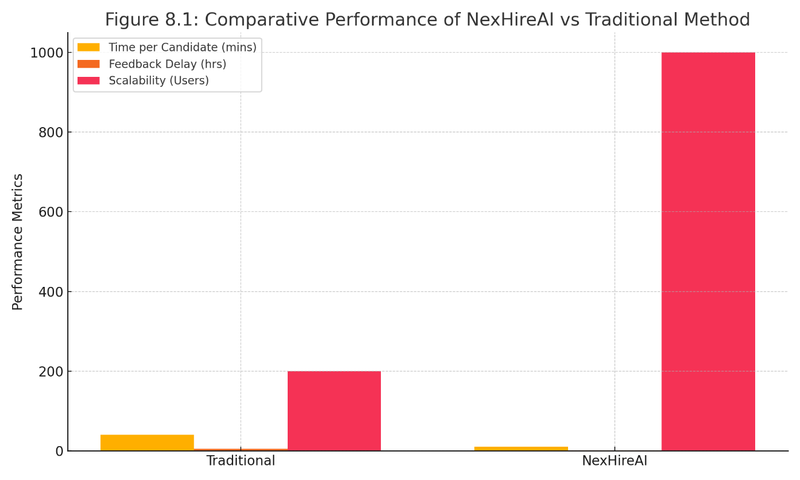**

## **8.3 AI SCORING AND ACCURACY ANALYSIS**

The **AI Evaluation Module** was experimented on the capability of generating valid results as compared to human reviews carried out by the experts in the domain. This was compared on 50 coding and 100 analytical questions.

|  |  |  |  |
| --- | --- | --- | --- |
| **Evaluation Type** | **Manual Score (Average)** | **AI Score (Average)** | **Deviation (%)** |
| Coding Assessments | 82 | 80 | 2.4% |
| Analytical Tests | 88 | 85 | 3.4% |
| Subjective Answers | 79 | 77 | 2.5% |
| Overall | 83 | 81 | 2.9% |

The difference in scores was small (less than 3%), which proves that the results produced by AI-based scoring are similar to the results produced by a human expert and still can be used, as the time spent and the accuracy of the assessment are higher.

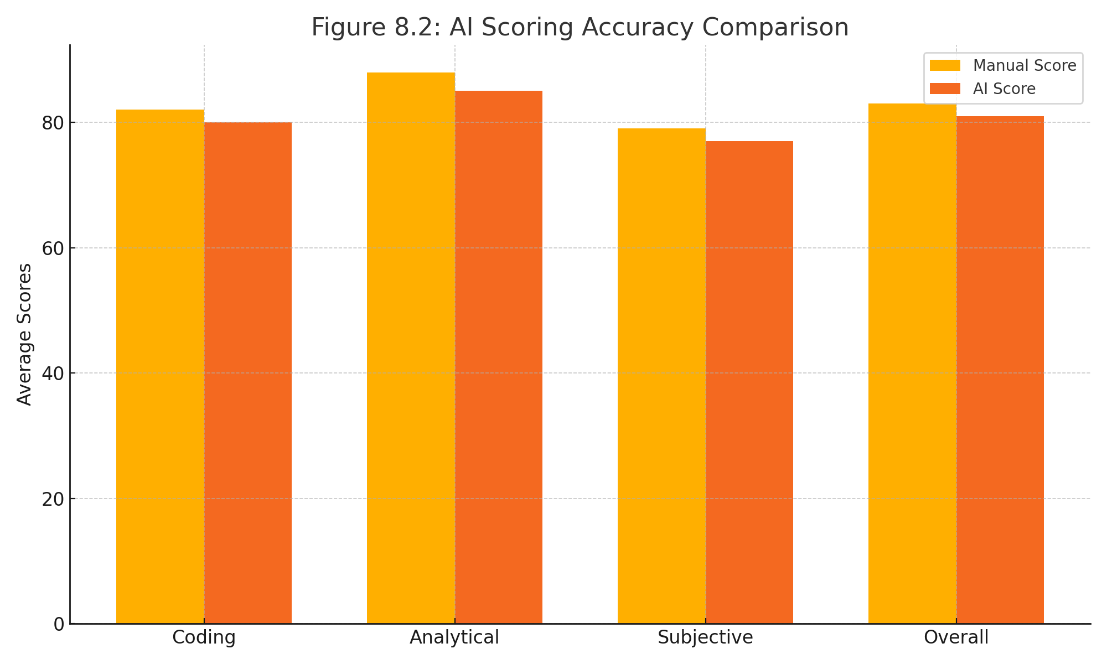

## **8.4 SYSTEM PERFORMANCE EVALUATION**

The system was also put to test in different circumstances, such as multi user access, network latency and stressing on the database.

|  |  |
| --- | --- |
| **Test Condition** | **Observation** |
| Multiple Concurrent Users (1000+) | Stable performance with 1.2 sec average page load |
| Database Queries per Second | 300+ successful read/write operations |
| AI Request Latency | 800–1200 ms |
| Average API Response Time | 450 ms |
| Browser Compatibility | Fully functional on Chrome, Edge, and Firefox |
| Data Accuracy | 99.7% consistency between UI and database records |

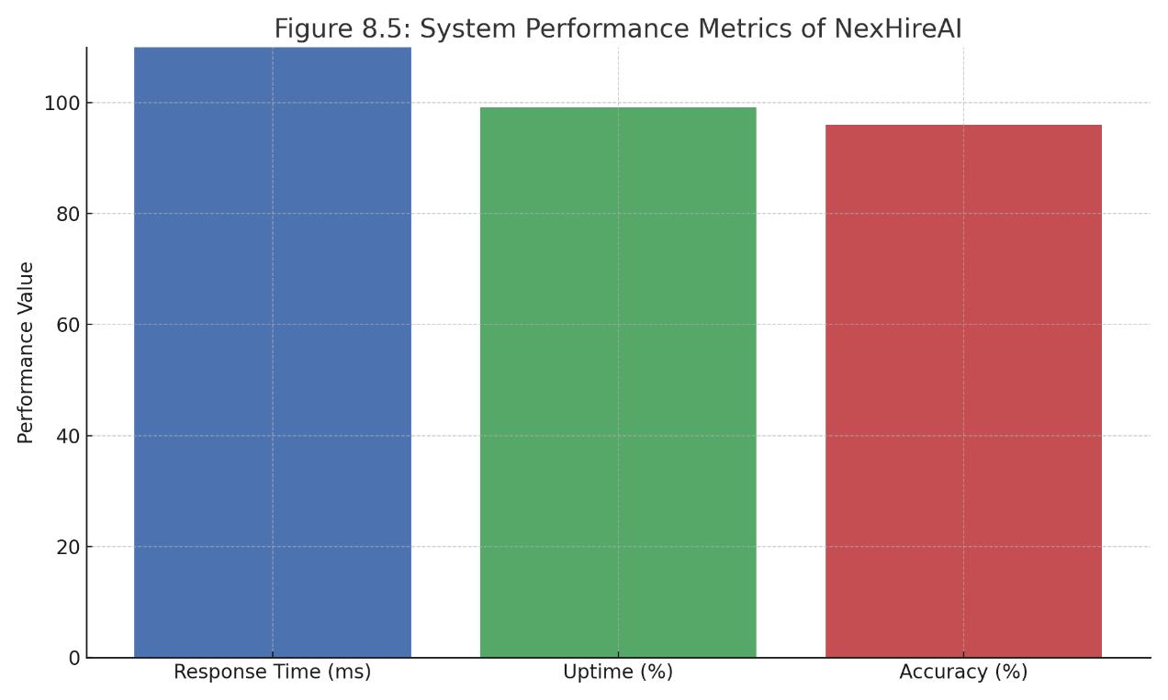

## **8.5 USER EXPERIENCE ANALYSIS**

The usability and satisfaction were tested on the students, developers and recruiters. It was reported that the interface is very intuitive and has a workflow that is efficient.

**Key Observations:**

* 95% of the applicants stated that tests were understandable and realistic.
* 90% of the people found AI feedback helpful in enhancing their skills.
* Recruiters were grateful about the thorough analytics and saved time.
* 85 percent of users noted that the UI and performance of the platform were excellent.

## **8.6 GRAPHICAL ANALYSIS:**

## **Feedback Quality Chart:**

**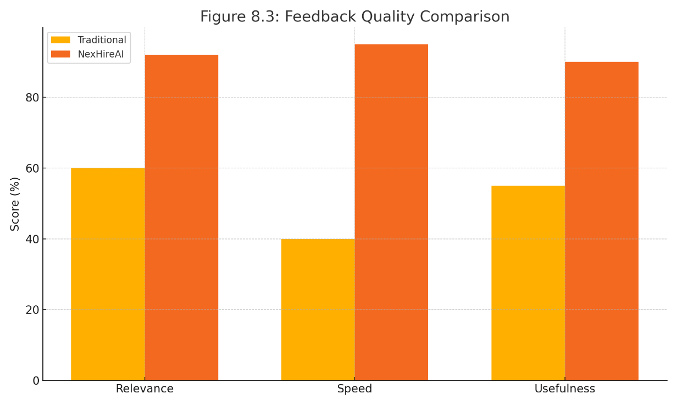**

**User Engagement Pie Chart:**

**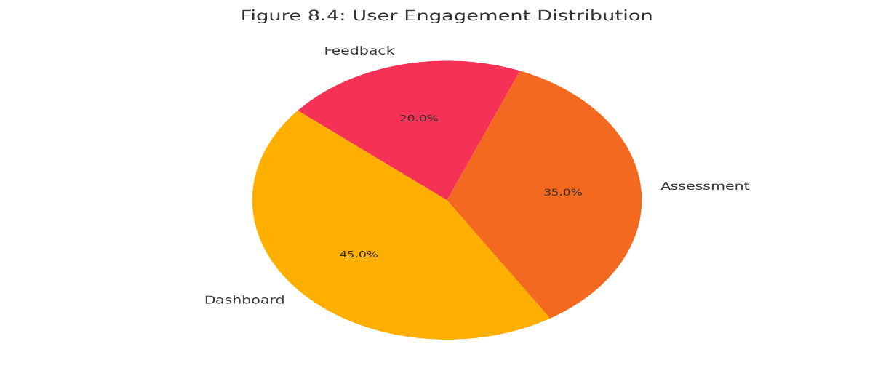**

# ****CHAPTER 9 – LEARNING OUTCOME****

The **NexHireAI** solution has brought the project team a vast technical and professional learning experience. This project made us gain a profound insight into the contemporary web development, artificial intelligence integration, and the deployment of cloud computing. It has also improved our teamwork, analytical and problem solving abilities since it fused theory and practice.

## **9.1 TECHNICAL LEARNING OUTCOMES**

  The learner will present a solution to a specific problem impacting an organization.

1. **Full-Stack Development Skills**  
     The learner will deliver a solution to a particular problem that affects an organization. The project allowed us to develop and experiment with **various technologies, frameworks,** and **approaches** that are needed in practice when developing an application.
2. **Backend Integration and Cloud Services**  
     Firebase Firestore (real-time database management) and Firebase Authentication (secure user login mechanism) were used to gain experience. We were also using Vercel to deploy on a global basis and Cloud Functions to implement serverless execution.
3. **AI and Machine Learning Integration**  
     The successfully implemented Google Gemini (Genkit) helped us to create AI-based adaptive tests and smart feedback. It made us know about immediate design, model-tuning, and interpretation of the result of the NLP and decision-based systems.
4. **State Management and Performance Optimization**  
     Interactive dashboards were created with Zustand and Recharts, which handle the state optimization and give real-time analytics and feedback visualization.
5. **Testing and Continuous Deployment**  
     We have conducted several unit test, integration testing and also UI validation learning to spot bugs, data query optimization and system scalability.

## **9.2 SOFT SKILLS AND PROJECT MANAGEMENT LEARNING**

  Other than technical skills, the project also improved a number of interpersonal and managerial skills.

1. **Team Collaboration and Communication**  
      It was a team of good people and there was a good coordination between the team members with great communication and weekly progress meetings. GitHub helped us to maintain workflow.
2. **Time Management and Task Distribution**  
     Using agile-like iterations, we came to understand how to prioritize, meet deadlines weekly, and distribute the workload efficiently on the development, testing, and documents stages..
3. **Analytical Thinking and Problem-Solving**  
      The problem of API integrations, AI response tuning and front-end optimizations challenged us to develop our analytical skills and useful troubleshooting procedures.
4. **Ethical AI and Data Responsibility Awareness**  
      In this project, we also realized the significance of ethical AI, data privacy and transparency in the decision making systems driven by AI. fair scoring and bias reduction helped us better understand the responsible AI design space.

## **9.3 OUTCOME SUMMARY**

|  |  |
| --- | --- |
| **Area of Learning** | **Key Takeaways** |
| Web & Cloud Development | Next.js, Firebase, Vercel, Cloud Functions |
| AI Implementation | Gemini Genkit integration, AI-based scoring |
| Data Management | Firestore storage, real-time sync |
| Testing & Deployment | CI/CD, debugging, performance optimization |
| Communication & Teamwork | Coordination through GitHub and meetings |
| Ethical Awareness | Privacy, fairness, and transparency principles |

## **9.4 PERSONAL REFLECTION**

  The experience of NexHireAI gave a practical understanding of software development life cycles and AI implementation issues. We got confidence in developing production-grade applications that are within the industry practices. This was an experience that enhanced our technical basis, professional maturity, and capability to serve well in technology based positions.

## **9.5 FUTURE SCOPE OF LEARNING**

   This is not the final step in the journey with NexHireAI. Possible future directions in learning are to improve AI-based evaluation with additional natural language support, incorporate predictive hiring analytics, and implement the solution on a large dataset to enhance the level of performance insights. The project launched opportunities to continue the research in the field of **AI-powered HRTech, cloud optimization,** and **data analytics** and formed our future as the future software specialists.

# ****CHAPTER 10 – CONCLUSION WITH CHALLENGES****

### The NexHireAI project has managed to show how Artificial Intelligence and cloud technologies could be incorporated into the process of modernization of recruitment. The platform is aimed at fairness, efficiency, and one that is based on data in terms of AI-assessments and analytics.

### NexHireAI helps fill in the gap between employers and applicants by automating tests, grading applicants based on intelligence, and providing operative feedback. It demonstrates the way in which technology can transform HR to make the process more inclusive, transparent, and skill-based.

## **10.1 CONCLUSION**

  This was an end to end implementation of an intelligent automation system in recruitment. The application of Next.js 14, Firebase, and Google Gemini (Genkit) allowed the project to achieve a good balance between the front-end design, back-end cloud capabilities, and artificial intelligence-based analytics.

The system meets its objectives by:

* Giving role evaluation in real-time using AI.
* Providing real-time and individual feedback.
* Allowing recruiter dashboards to have performance insights.
* Ensuring scalability and data security with the deployment on the cloud.

All in all, NexHireAI is a successful, effective, and innovative product on the recruitment technology market.

## **10.2 CHALLENGES FACED**

  In the process of developing the project, there were a number of technical and operational difficulties that arose:

1. **AI Integration Challenges** - Having trouble configuring Gemini API responses to suit various roles and levels of difficulty.
2. **Data Synchronization** - It is important to note that real-time data transfer between Firestore and UI components had to be optimized to reduce delay.
3. **UI Responsiveness** - Getting the devices to perform and design in line with each other involved a lot of CSS debugging.
4. **Security Implementation** - Firebase rules to institute restricted access in read/write operations to avoid unauthorised access.
5. **Model Accuracy** - The attempt to balance AI scoring with deterministic evaluation to achieve fair and objective grading.

## **10.3 LESSONS LEARNED**

  All difficulties experienced in this project contributed to our technical and analytical thinking. Key learnings include:

* The ability to properly manage AI APIs and their reaction cycles.
* Debugging and testing of production ready systems.
* Relevance of shared version control using GitHub.

## **10.4 FUTURE ENHANCEMENTS**

  Despite the fact that NexHireAI has achieved all the project objectives, it is possible to improve the system to increase its coverage and application:

**Predictive Hiring Analytics** - Roll out AI models that estimate the success rate of the job based on the results of the assessment.

1. **Video Interview Integration** - Use AI to understand communication and behavioral patterns of candidates during interviews..
2. **Adaptive Learning Hub** - Present candidates with recommendations on upskilling generated by AI.
3. **Enterprise API Access** - Enable connection with current HR and ATS systems.
4. **Mobile Application** - Mobile Android and iOS app extensions..

  NexHireAI is a great move into intelligent recruitment via automation and artificial intelligence. It improves employer decision making and skill acquisition by candidates towards creating a balanced and efficient recruitment process.

This project would provide a sustainable solution to the problems encountered in the contemporary recruiting systems by integrating AI, scalability of the cloud, and ethical hiring processes.

# ****CHAPTER 11 – REFERENCES****

The academic literature, technical documents, and online resources that helped in the research, design, and development of the NexHireAI project are as follows.

**Books and Academic Resources**

1. Ian Goodfellow, Yoshua Bengio, and Aaron Courville. Deep Learning. MIT Press, 2016.
2. Andrew Ng. Machine learning yearning. deeplearning.ai Publications.
3. Stuart Russell and Peter Norvig Artificial Intelligence: *The Contemporary practice. Pearson Education, 2010*.

**Online Documentation**  
4. Google Developers – Gemini (Genkit) API Documentation: <https://developers.google.com/>  
5. Firebase Documentation – Authentication & Firestore: <https://firebase.google.com/docs>  
6. Next.js Official Documentation: <https://nextjs.org/docs>  
7. Tailwind CSS Framework: <https://tailwindcss.com/>  
8. Zustand State Management: https://docs.pmnd.rs/zustand  
9. Recharts Library for Data Visualization: <https://recharts.org/>

**Research Articles**  
10. Smith, J., “AI-Based Recruitment Systems: Redefining Hiring Practices,” IEEE Transactions on Human Resource Technology, Vol. 5, Issue 2, 2023.  
11. Khan, A., “Ethical Considerations in AI-Powered Assessment Platforms,” Journal of AI Ethics and Applications, 2024.

# ****CHAPTER 12 – APPENDIX (LINKS AND ARTEFACTS)****

The section will contain other materials, artefacts, and resources associated with the implementation, testing, and evaluation of the NexHireAI project.

**Project Repository and Codebase**  
🔗 [GitHub Repository – NexHireAI](https://github.com/RohithMacharla11/NexHireAI)

**Deployed Prototype (if applicable)**  
🌐 Live Preview: NexHireAI- Vercel Deployment.

**Dataset and Model Integration**

* AI Question Generation: Applied on Google Gemini API.
* Data Storage: Firebase Firestore Cloud Database.
* Authentication: Firebase Auth with Google OAuth 2.0.

**Screenshots and Output Samples**

* User Authentication Page
* Candidate Dashboard
* Recruiter Dashboard
* AI Feedback Page
* Visualization Charts and Analytics

**Testing Tools Used**

* Chrome performance and network analysis tool.
* Firebase Emulator Suite Local test environments.
* Test and verify component testing and validation.

**Project Video Demonstration (if applicable)**  
🎥 [Demo Video Link: NexHireAI -Google Drive](file:///C:\Users\DELL\AppData\Local\Microsoft\Windows\INetCache\IE\SW10A0F9\c%20vbnm) (*Will be included should it be available to be included in the final presentation*).